***CSA1178-OBJECT ORIENTED ANALYSIS AND DESIGN***

***LAB DAY-5***

**33)JEWEL LOAN MANAGEMENT SYSTEM USE CASE DIAGRAM:**

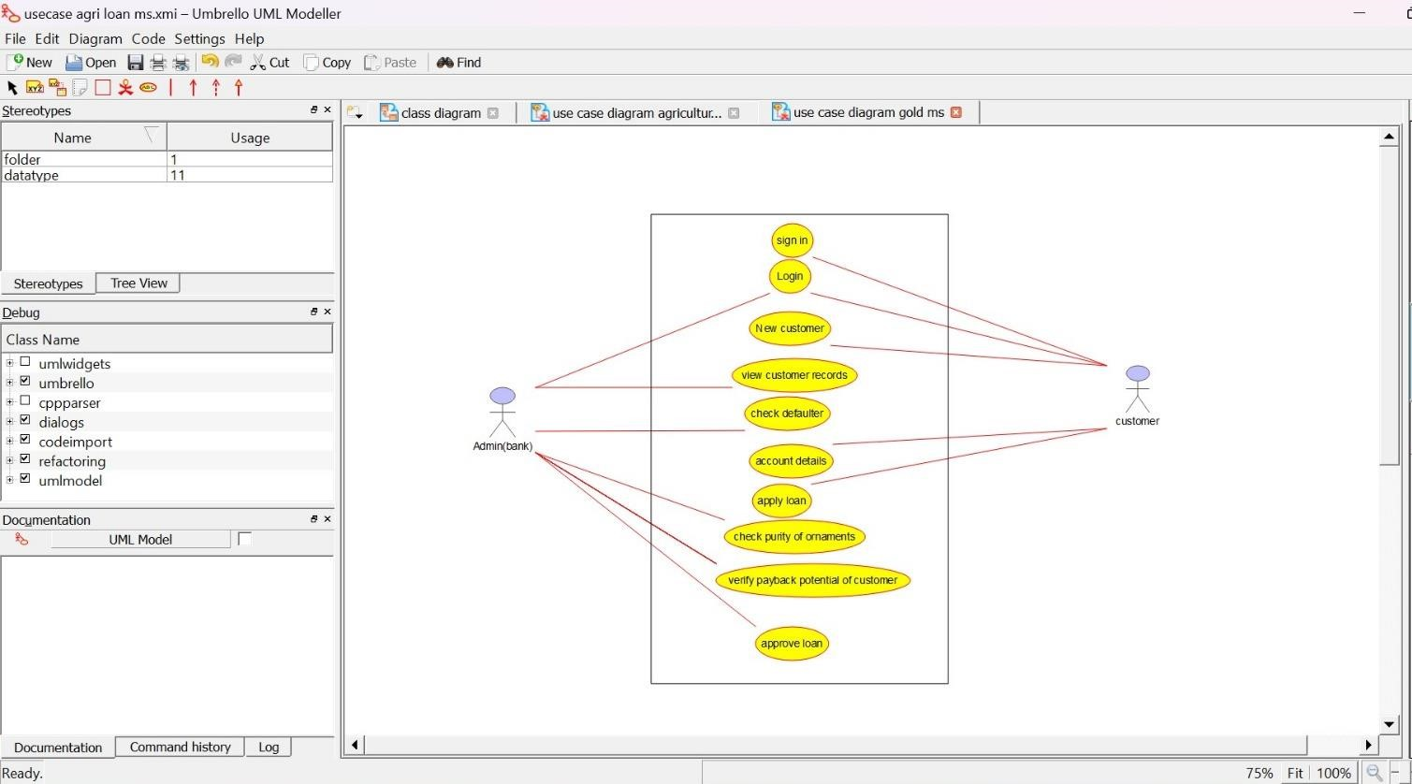

**CLASS DIAGRAM:**

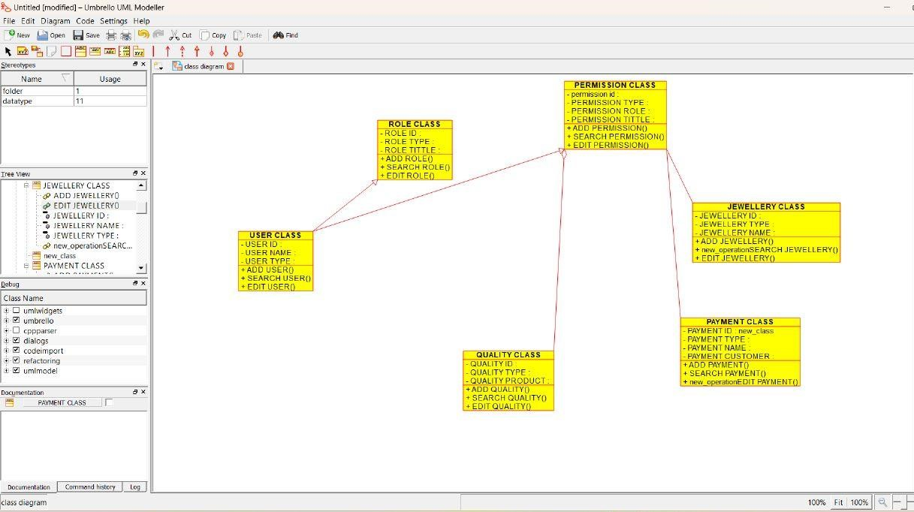

**ACTIVITY DIAGRAM:**

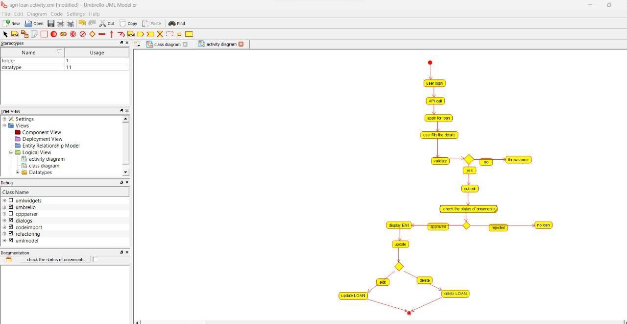

**34)PERSONAL LOAN MANAGEMENT SYSTEM USE CASE DIAGRAM:**

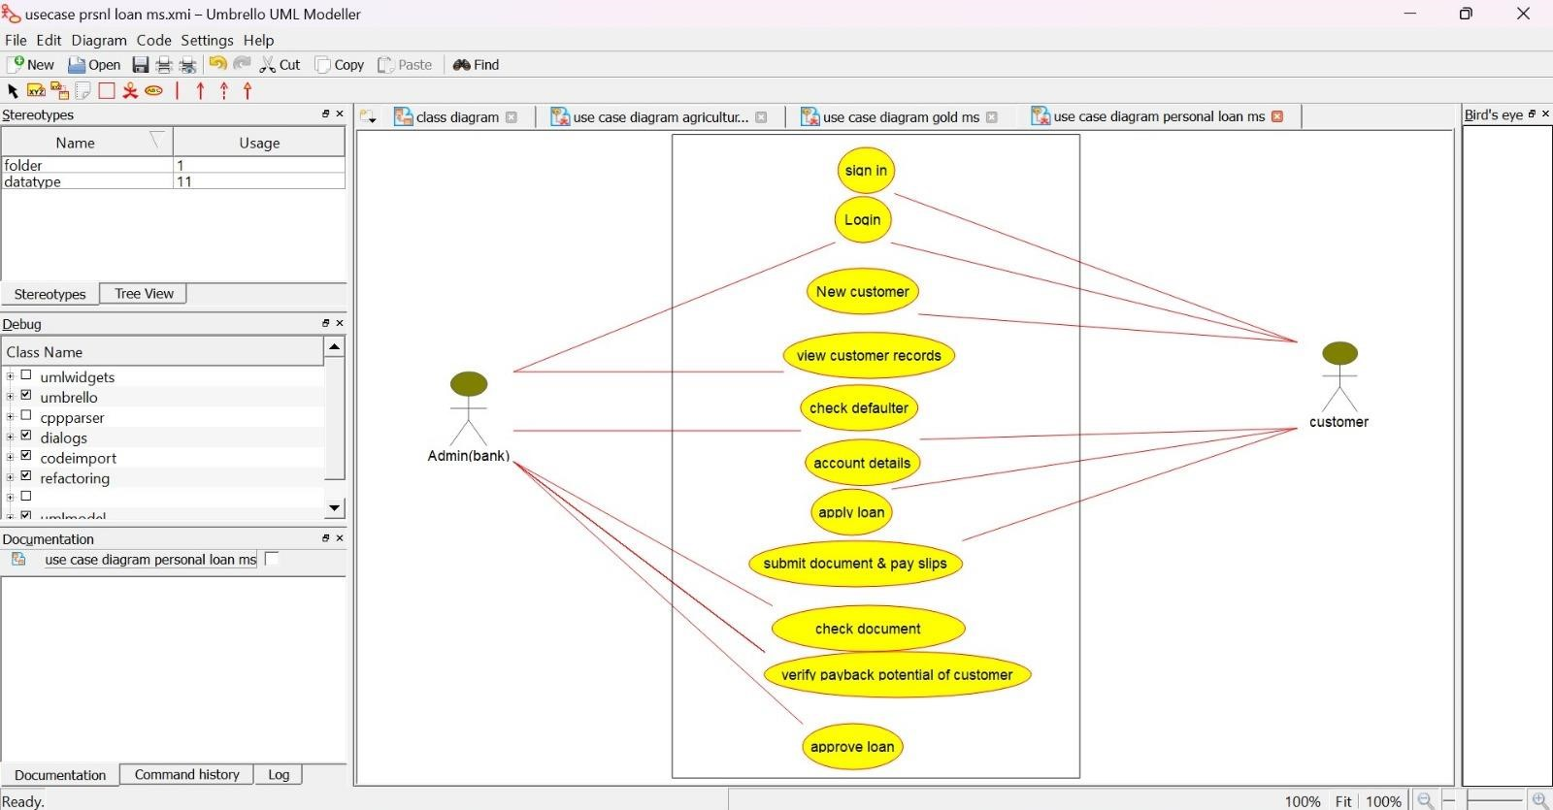

**CLASS DIAGRAM:** 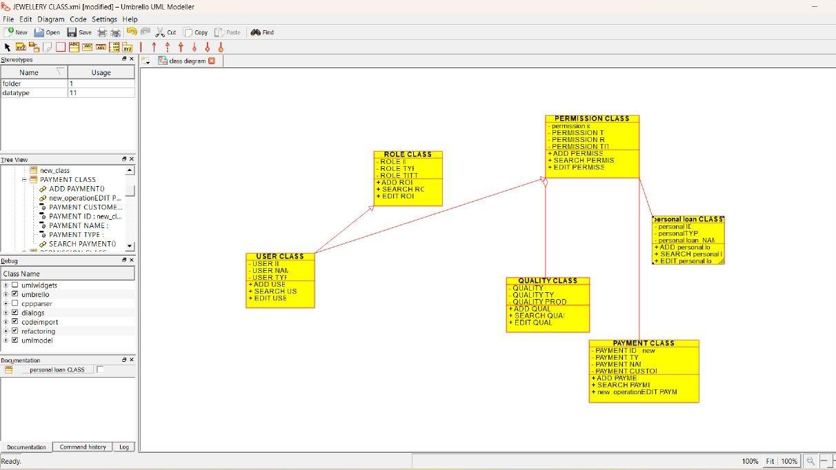

**SEQUENCE DIAGRAM:**

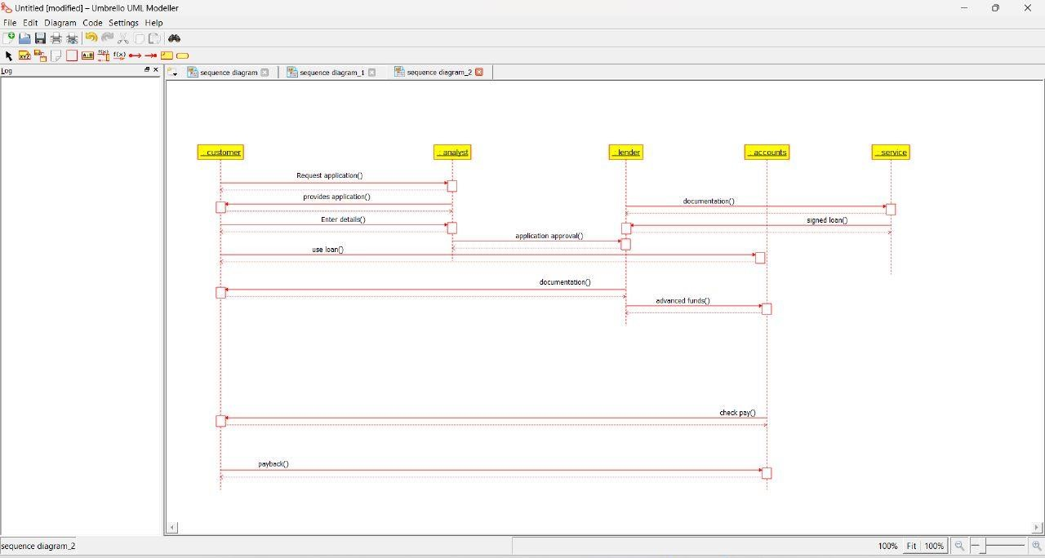

**35)HOME LOAN MANAGEMENT SYSTEM USE CASE DIAGRAM:**

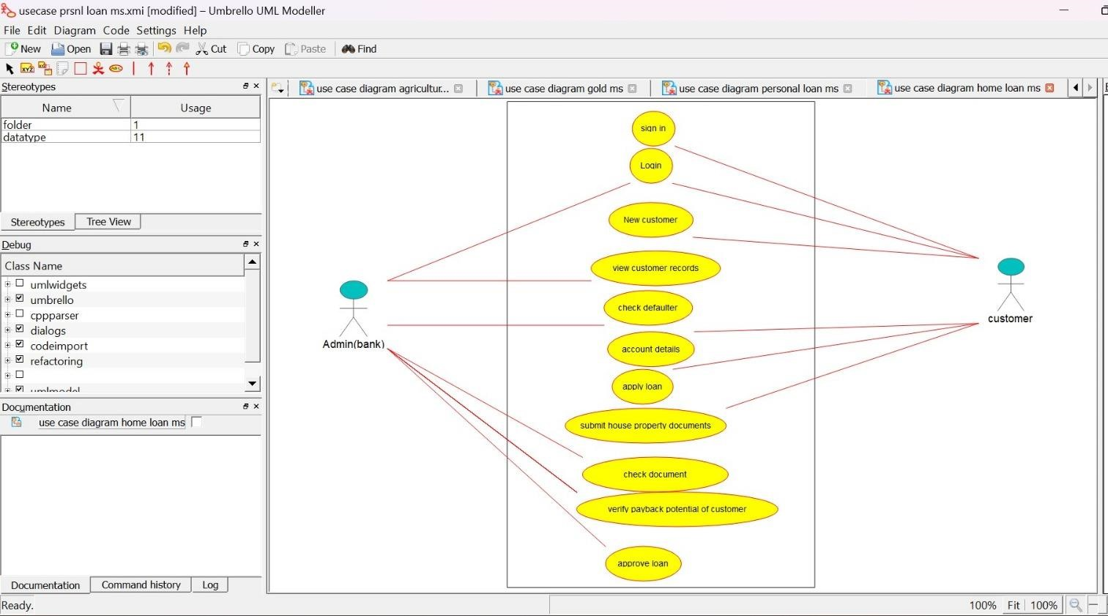

**CLASS DIAGRAM:**

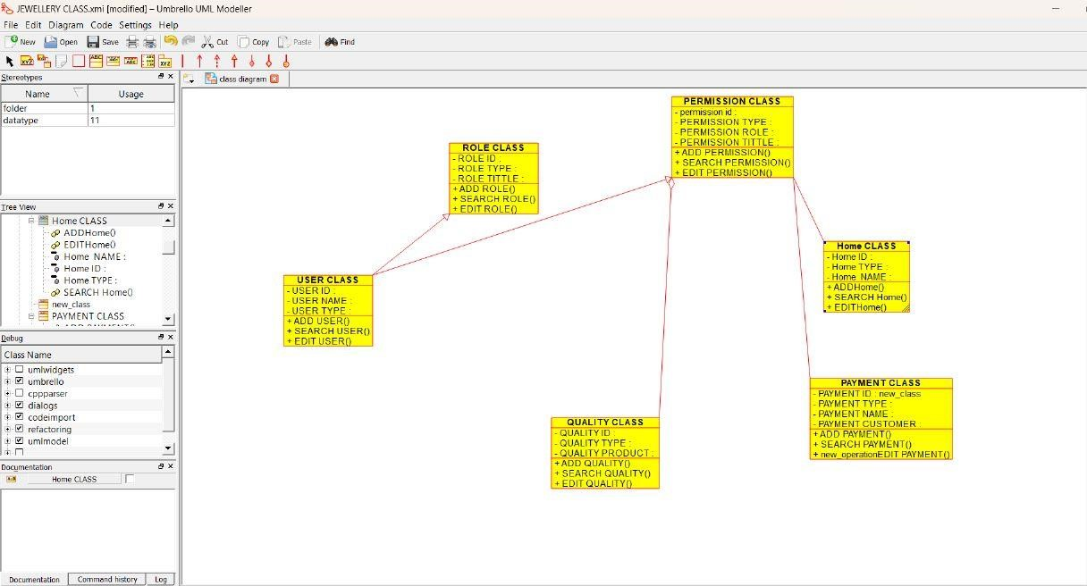

**ACTIVITY DIAGRAM:**

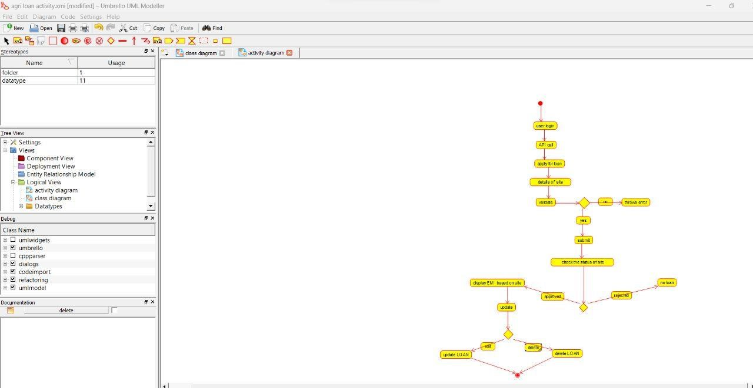

1. **LAND REGISTRATION SYSTEM**

**USE CASE DIAGRAM:**

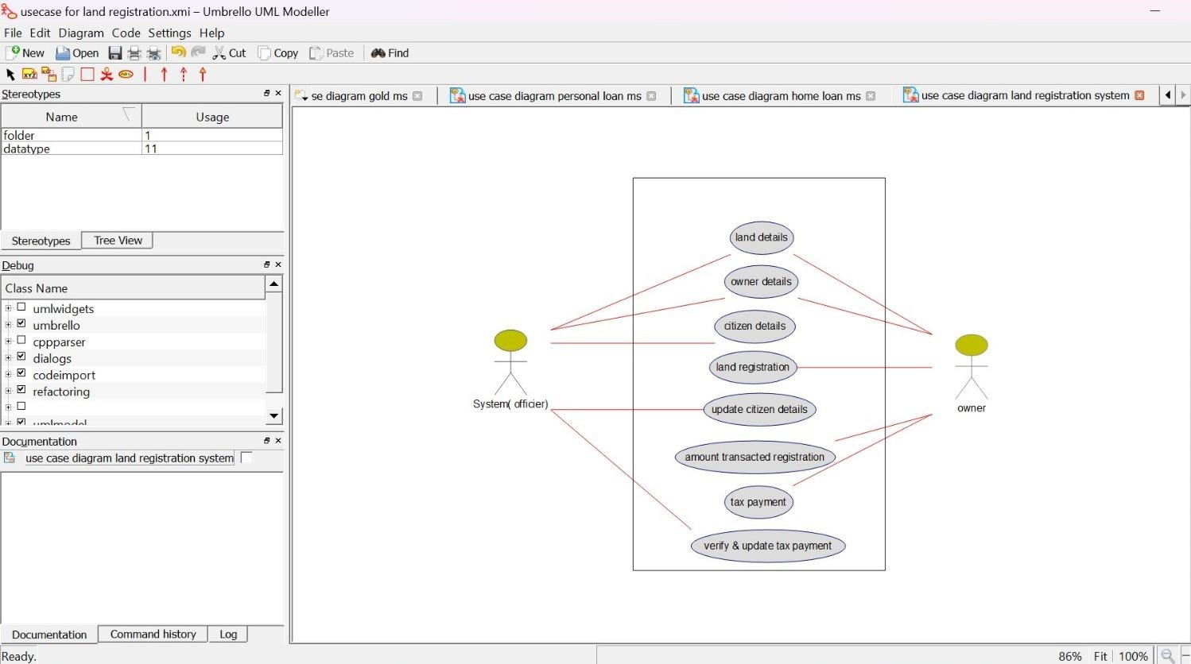

**CLASS DIAGRAM:**

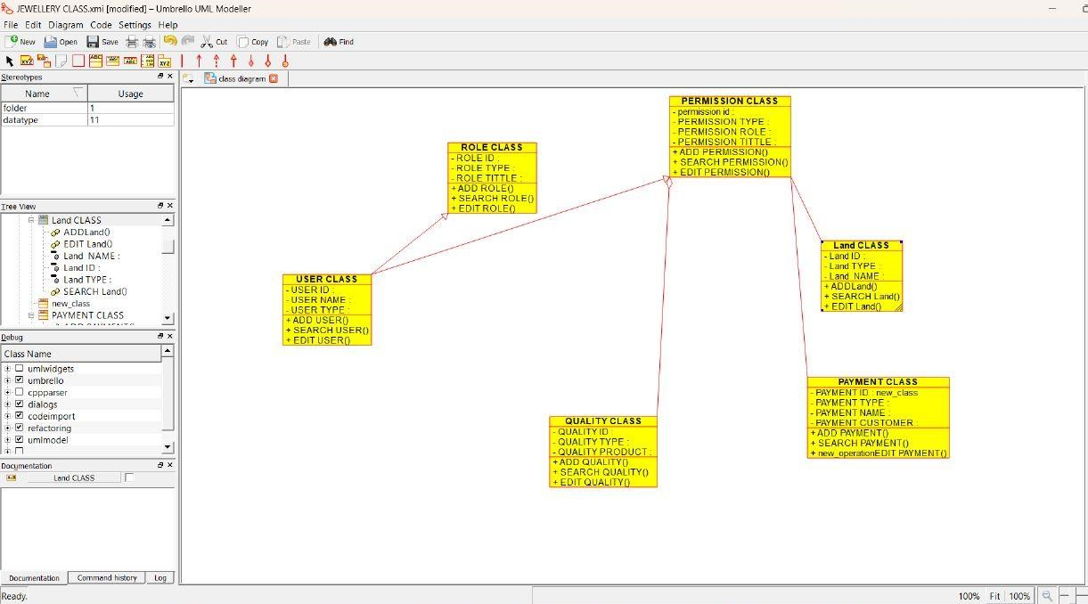

**ACTIVITY DIAGRAM:**

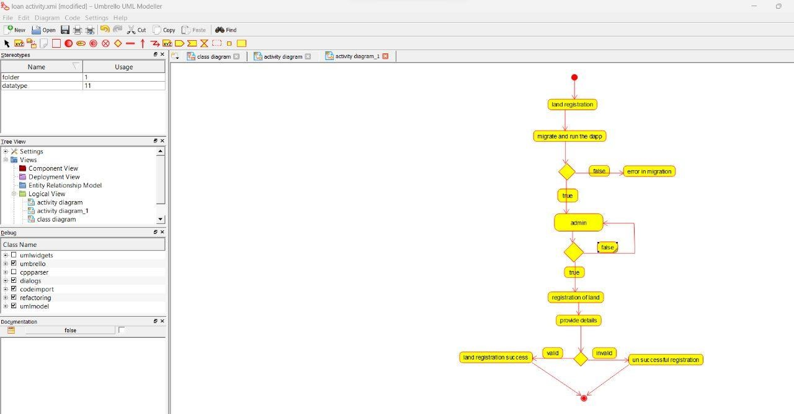

**36)VEHICLE BOOKING SYSTEM USE CASE DIAGRAM:**

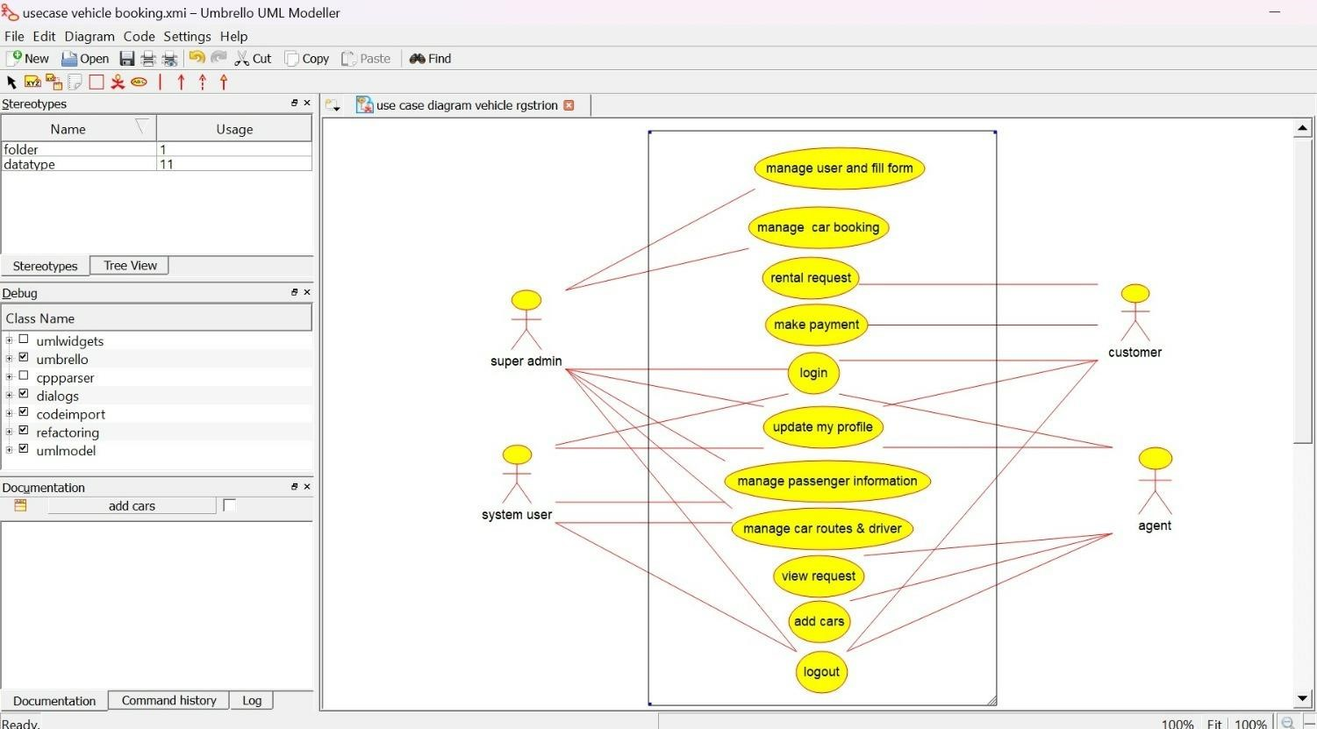

**CLASS DIAGRAM:**

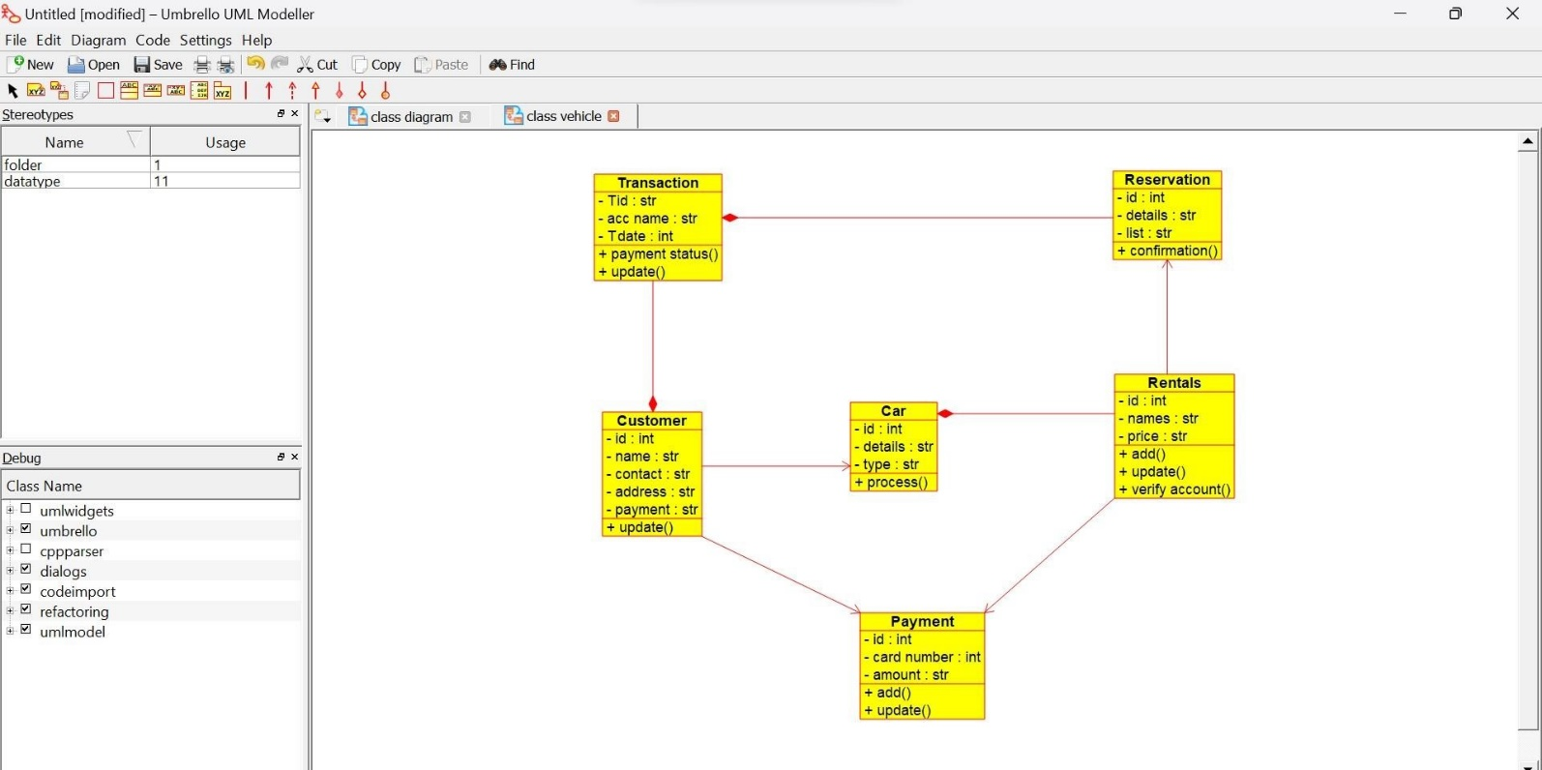

**SEQUENCE DIAGRAM:**

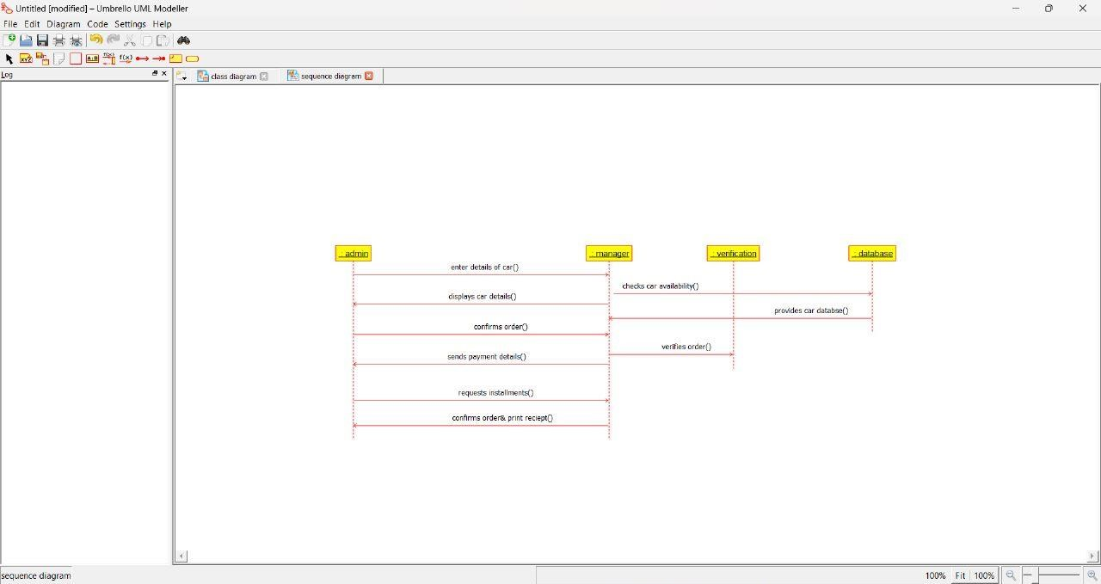

**37)DOCTOR APPOINTMENT SYSTEM USE CASE DIAGRAM:**

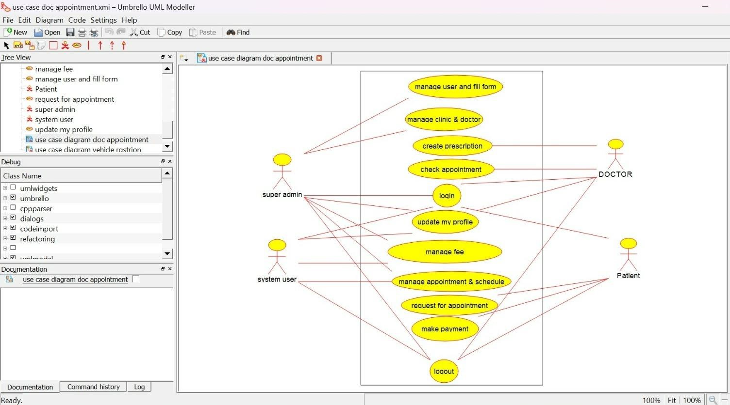

**CLASS DIAGRAM:**

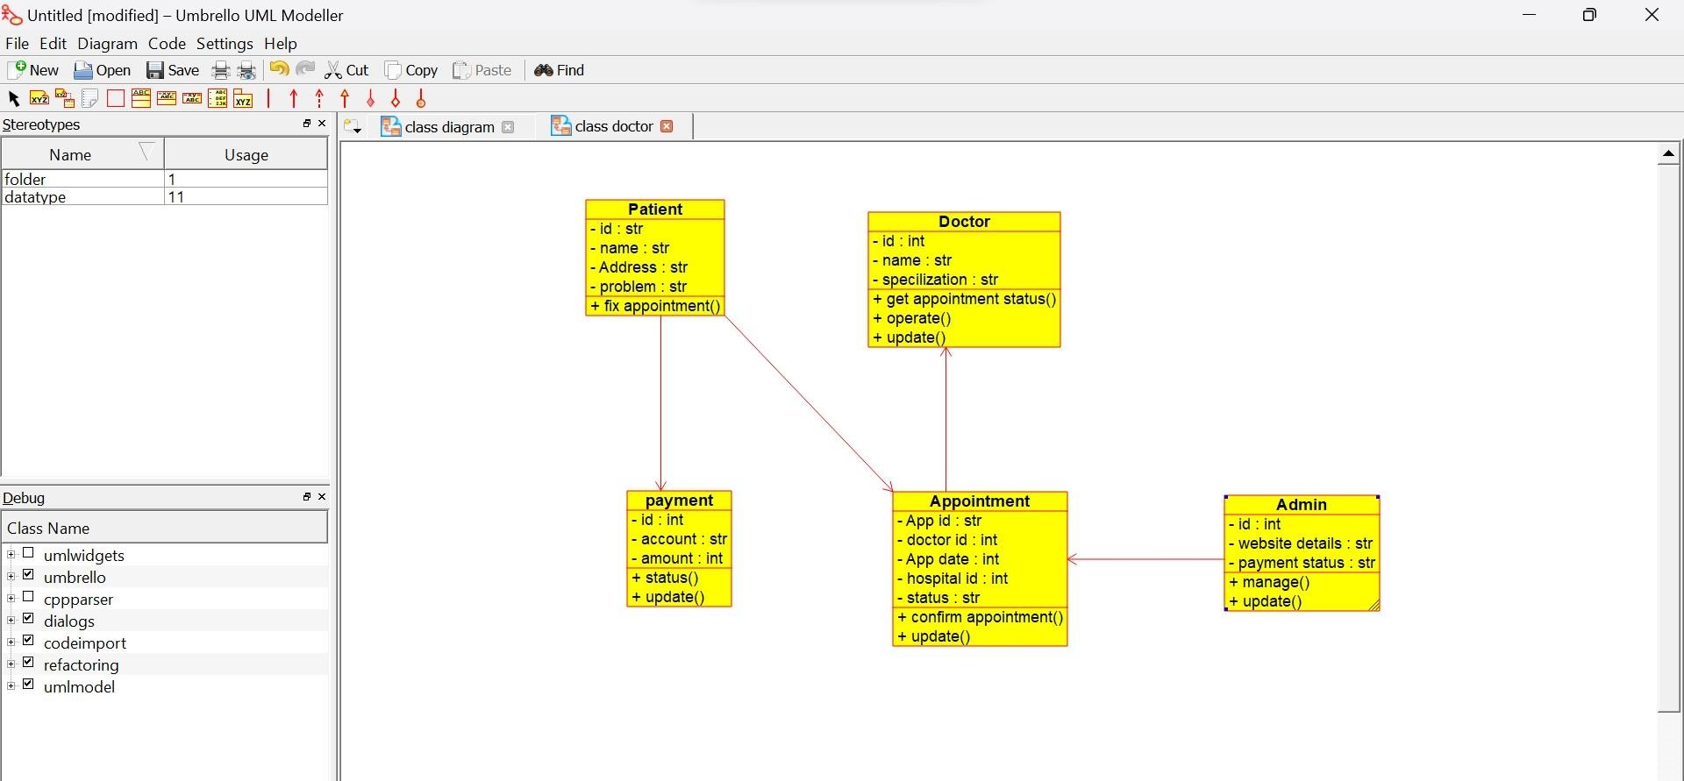

**ACTIVITY DIAGRAM:**

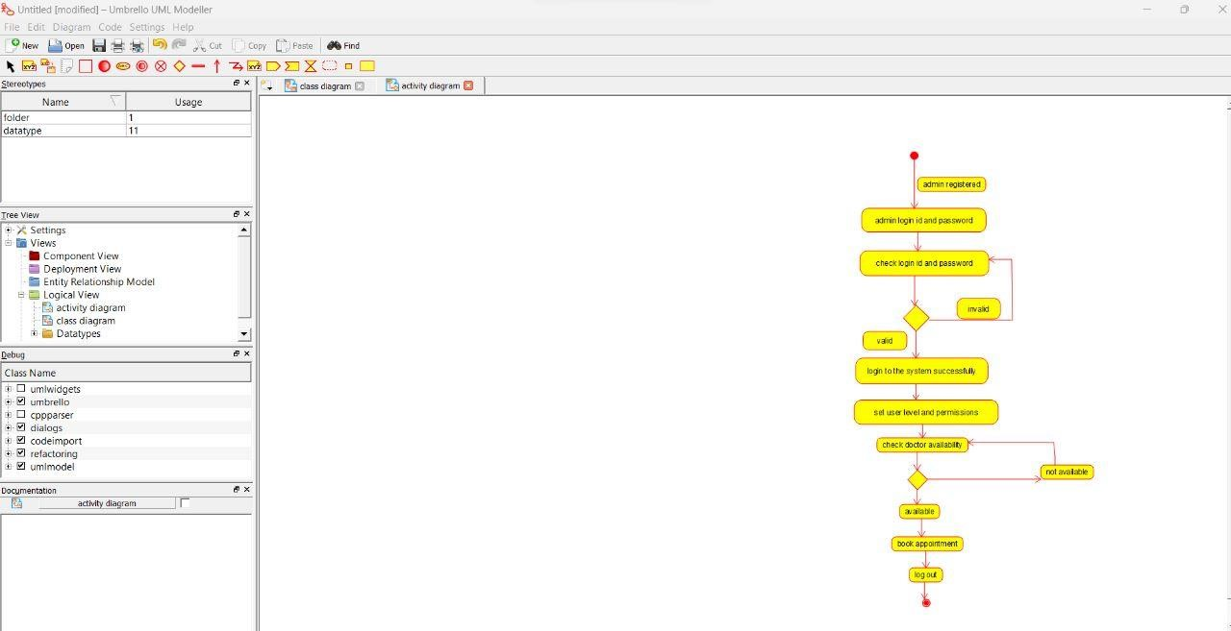

**38)PARLOR RESERVATION SYSTEM USE CASE DIAGRAM:**

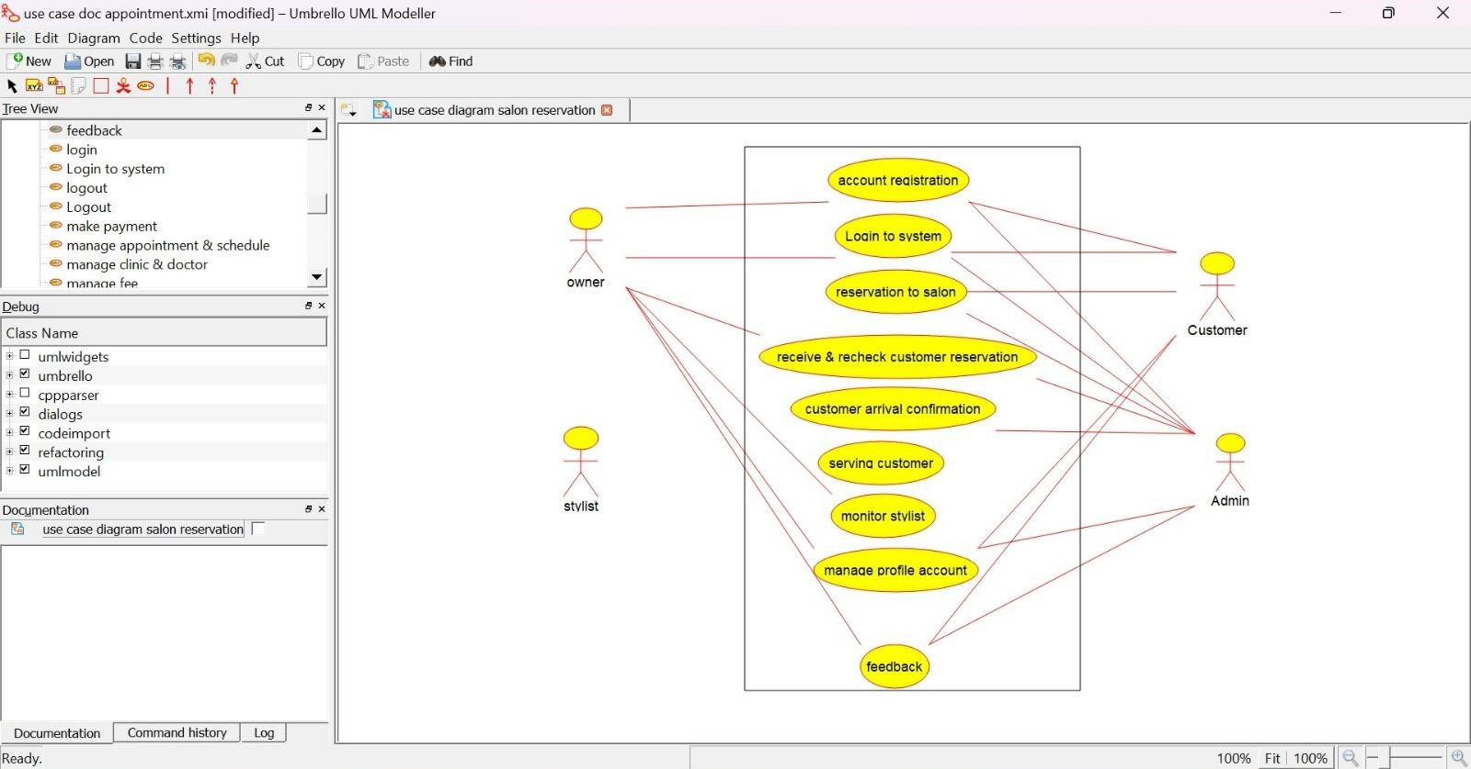

**CLASS DIAGRAM:**

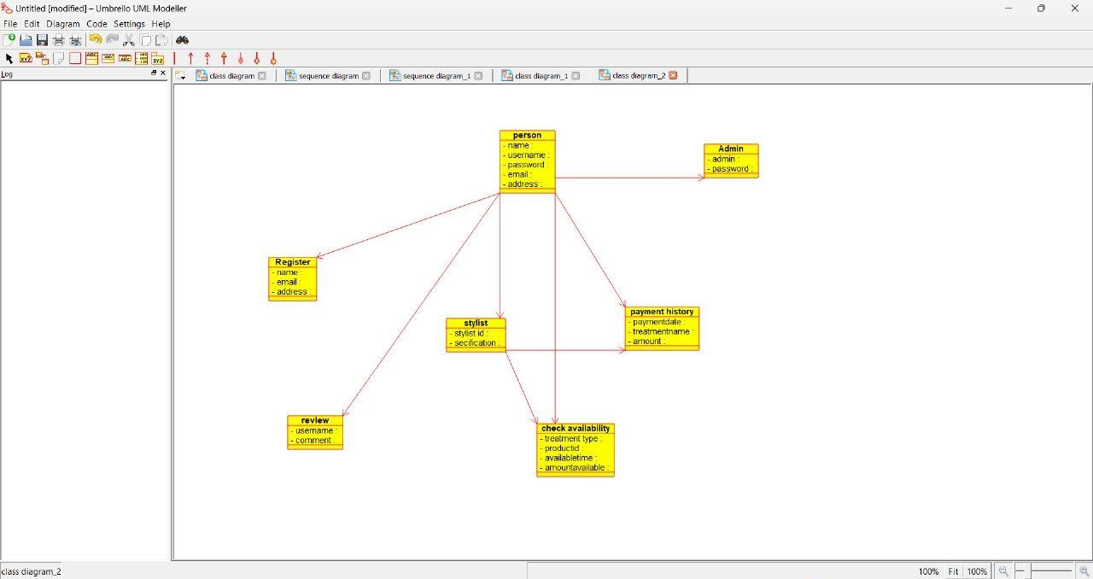

**SEQUENCE DIAGRAM:**

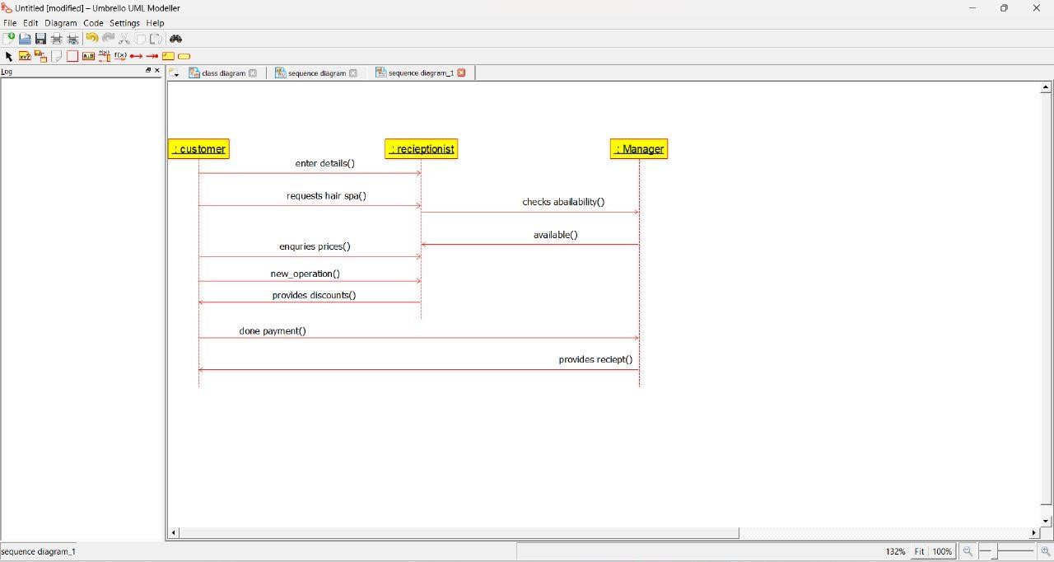

**39)GARDENER BOOKING SYSTEM USE CASE DIAGRAM:**

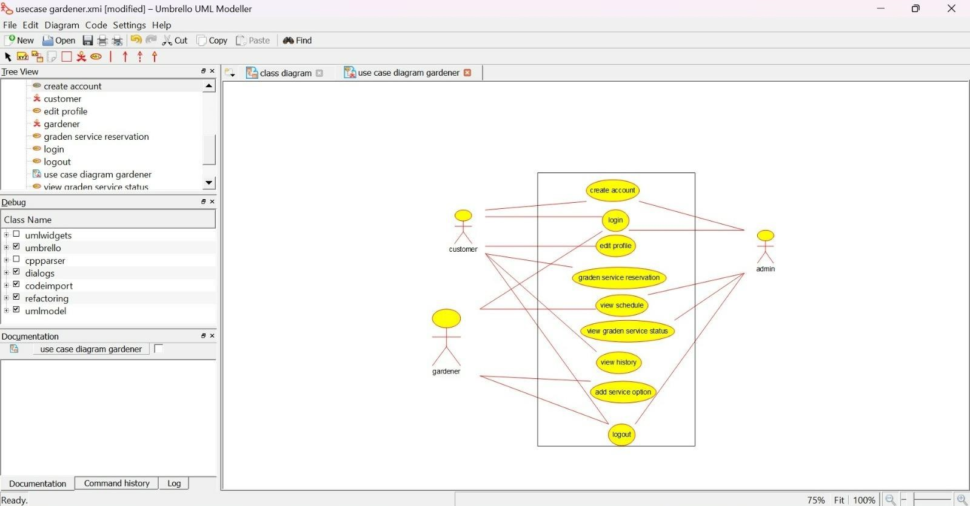

**CLASS DIAGRAM:**

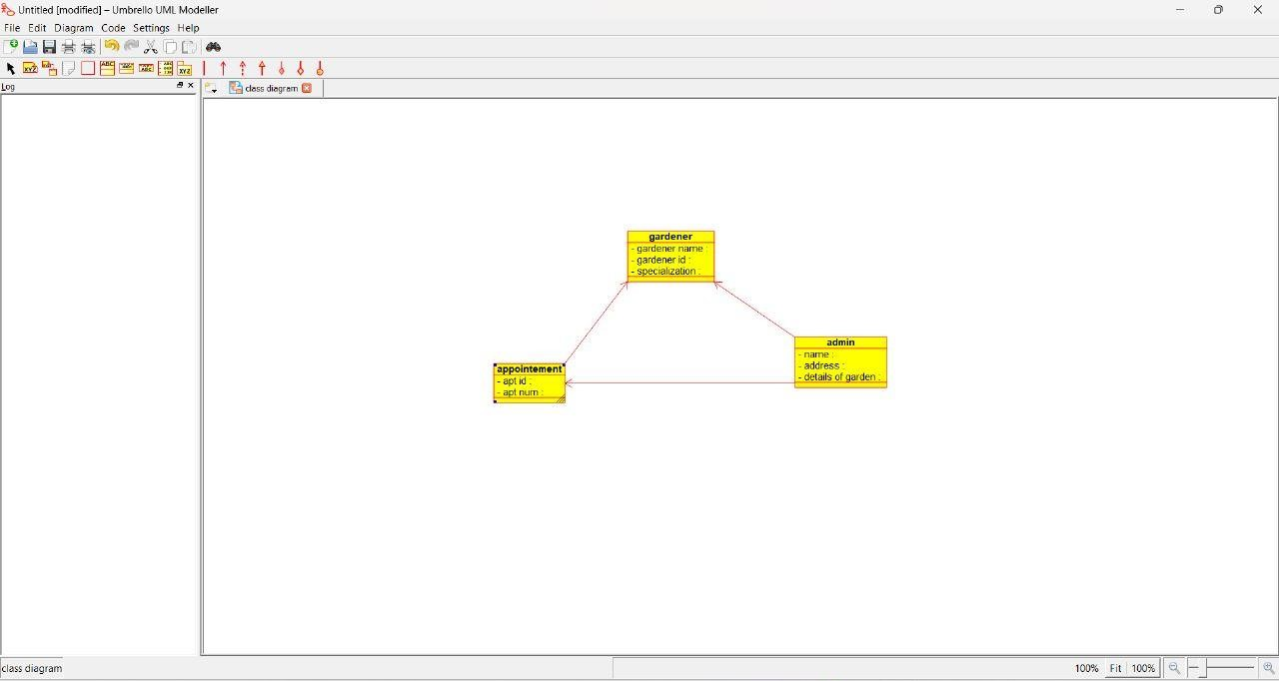

**SEQUENCE DIAGRAM:**

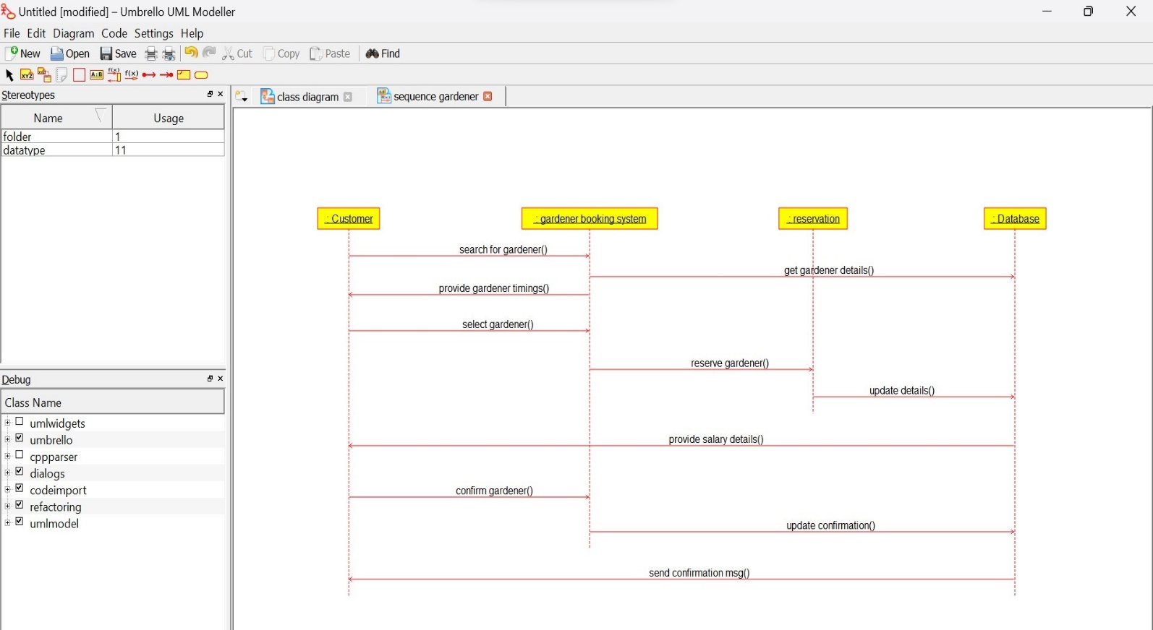

**40)HOME TAX COLLECTION SYSTEM USE CASE DIAGRAM:**

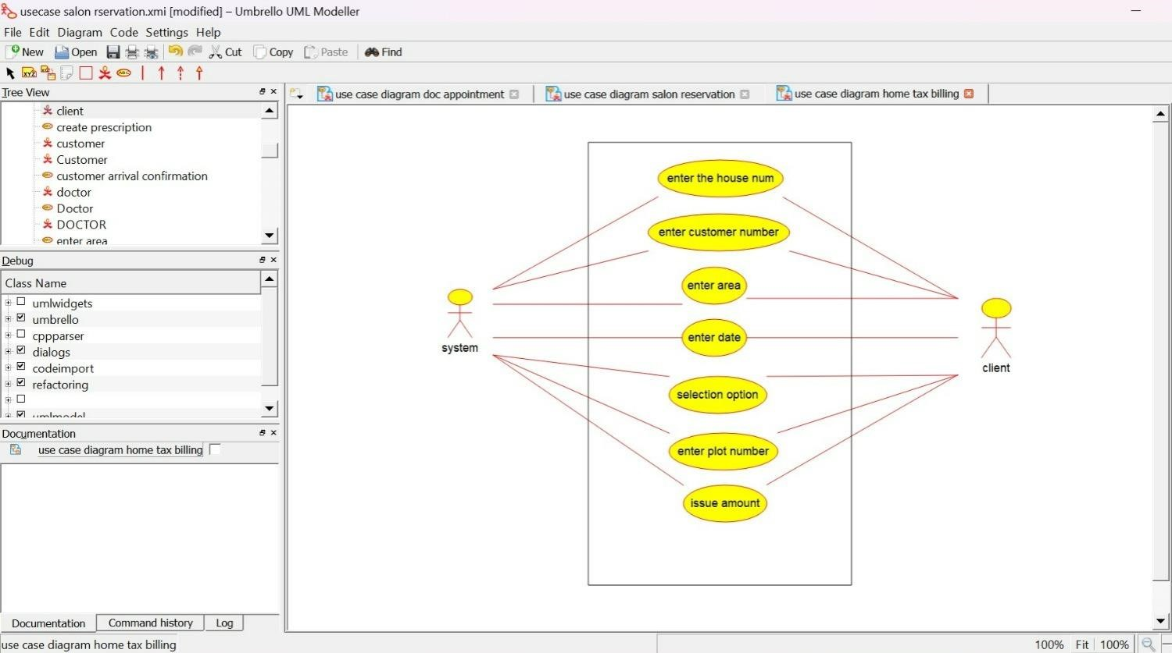

**CLASS DIAGRAM:**

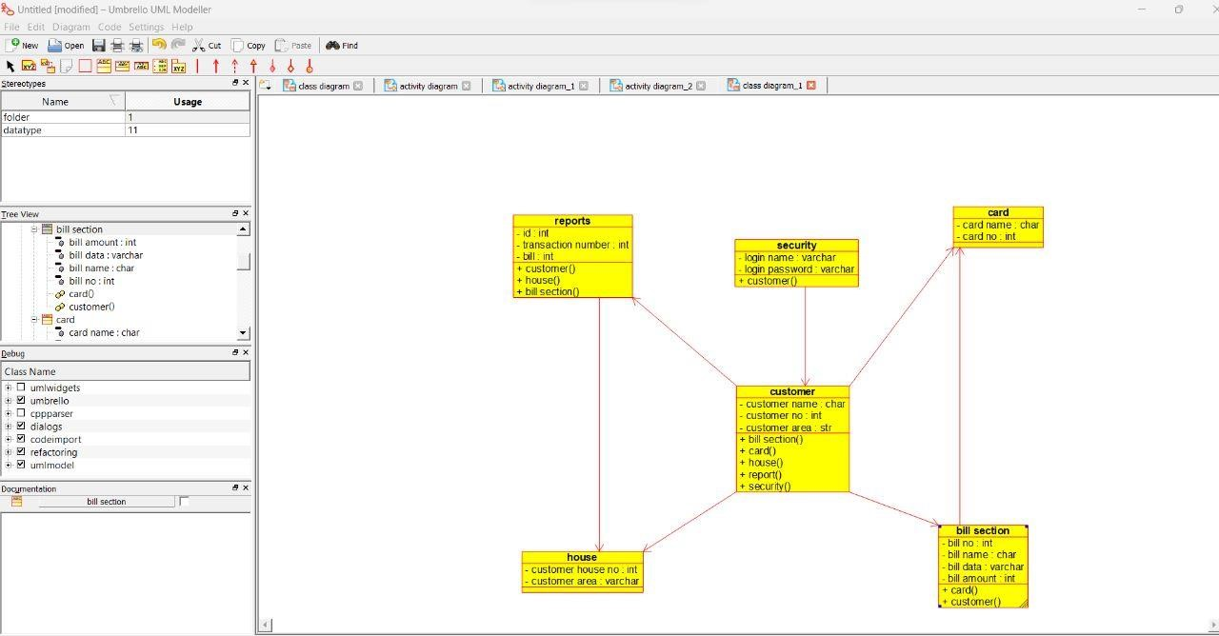

**ACTIVITY DIAGRAM :**

